**Introducing Tkinter with Raspberry pi**

**CIRCUIT DIAGRAM:**

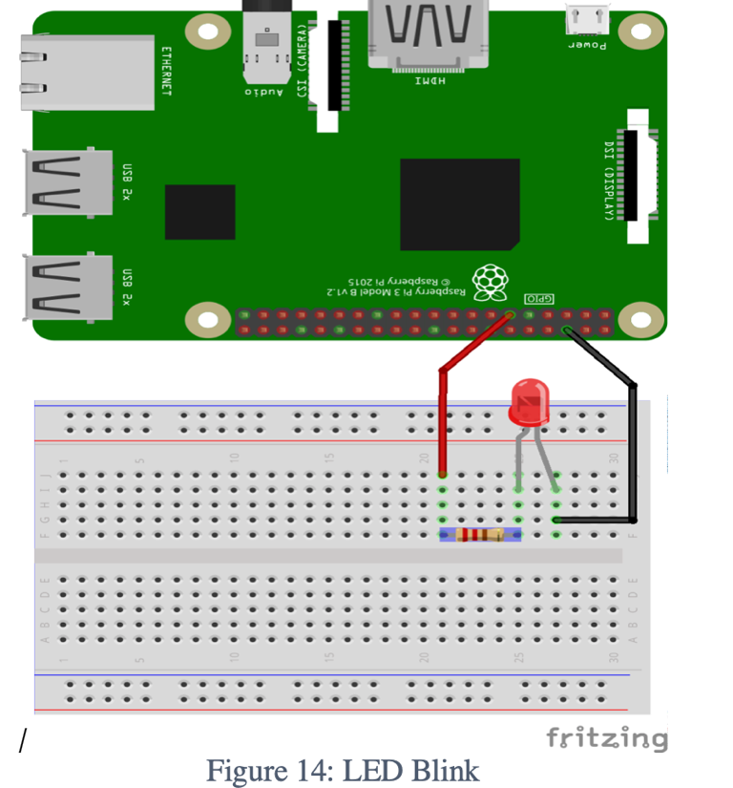

Code

*# import the important library*

**import** **tkinter** **as** **tk**

mainwindow=tk.Tk()

mainwindow.title('My First UI Test ')

mainwindow.geometry('640x340')

my_label=tk.Label(mainwindow,text=" On/Off ",

font=("Arial",22), bg= "Green",fg="white")

my_label.grid(row=0,column=0,sticky='NSEW',padx=10,pady=10)

button_on=tk.Button(mainwindow,text="On",bg="black",fg="white")

button_on.grid(row=1,column=0,sticky='NSEW',padx=10,pady=10)

button_off=tk.Button(mainwindow,text="OFF",bg="black",fg="white")

button_off.grid(row=1,column=1,columnspa=1,sticky='NSEW',padx=10,pady=10)

mainwindow.mainloop()

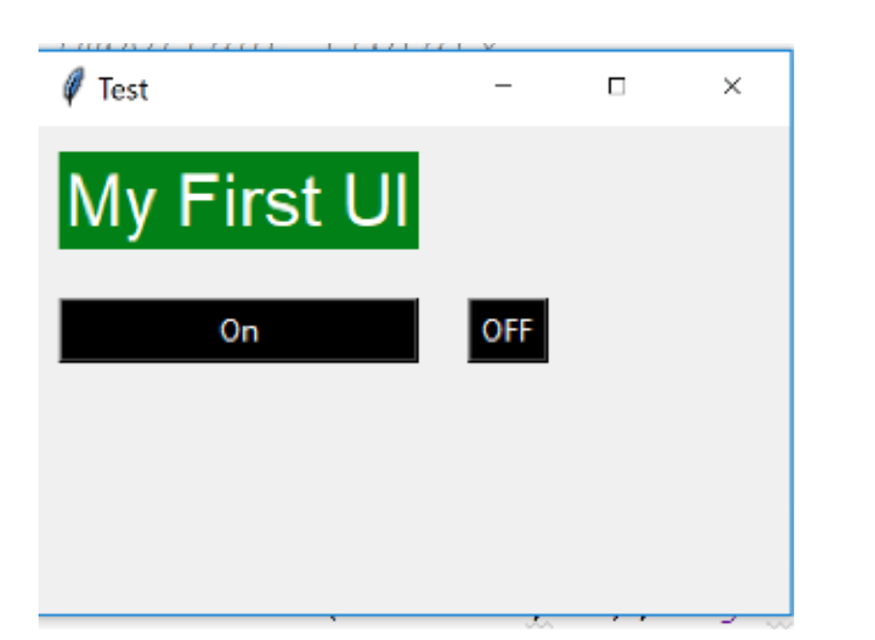

### **Step 2:** Adding Functionality to execute a function when Button is pressed using Lambda Function

*# import the important library*

**import** **tkinter** **as** **tk**

mainwindow=tk.Tk()

mainwindow.title('Test ')

mainwindow.geometry('640x340')

my_label=tk.Label(mainwindow,text="My First UI",

font=("Arial",22), bg= "Green",fg="white")

my_label.grid(row=0,column=0,sticky='NSEW',padx=10,pady=10)

button_on=tk.Button(mainwindow,text="On",bg="black",fg="white",

command=**lambda** :my_on())

button_on.grid(row=1,column=0,sticky='NSEW',padx=10,pady=10)

button_off=tk.Button(mainwindow,text="OFF",bg="black",fg="white",

command=**lambda**:my_off())

button_off.grid(row=1,column=1,columnspa=1,sticky='NSEW',padx=10,pady=10)

**def** my_on():

print('Led Turn On !!!!! ')

**def** my_off():

print('Led Turned Off !!!!!! ')

mainwindow.mainloop()

### **Step 3:** Add the Final code to Turn LED On/Off

*# import the important library*

**import** **tkinter** **as** **tk**

**import** **RPi.GPIO** **as** **GPIO**

**import** **time**

GPIO.setmode(GPIO.BOARD) *# to use Raspberry Pi board pin numbers*

GPIO.setup(11, GPIO.OUT) *# set up GPIO output channel*

mainwindow=tk.Tk()

mainwindow.title('Test ')

mainwindow.geometry('640x340')

my_label=tk.Label(mainwindow,text="My First UI",

font=("Arial",22), bg= "Green",fg="white")

my_label.grid(row=0,column=0,sticky='NSEW',padx=10,pady=10)

button_on=tk.Button(mainwindow,text="On",bg="black",fg="white",

command=**lambda** :my_on())

button_on.grid(row=1,column=0,sticky='NSEW',padx=10,pady=10)

button_off=tk.Button(mainwindow,text="OFF",bg="black",fg="white",

command=**lambda**:my_off())

button_off.grid(row=1,column=1,columnspa=1,sticky='NSEW',padx=10,pady=10)

**def** my_on():

print('Led Turn On !!!!! ')

GPIO.output(11, GPIO.LOW) *# set RPi board pin 11 low. Turn off LED.*

time.sleep(1)

print('Yes you did it !')

**def** my_off():

print('Led Turned Off !!!!!! ')

GPIO.output(11, GPIO.HIGH) *# set RPi board pin 11 high. Turn on LED.*

time.sleep(2)

print('Great Work ! ')

mainwindow.mainloop()